Q1.

a) Enumerate the following sets:

$Nums1=\left\{ x :Z \right| x>{}_{}^{-}{1 \bigwedge{<4} }\}$

{0,1,2,3}

$Nums2=\left\{ x :Z \right| x^{2}<26\}$

{-5,-4,-3,-2,-1,0,1,2,3,4,5}

$Nums3=\left\{ x : N_{1}\right| x^{3}<65 \}$

{1,2,3,4}

1. marks)

b) Descriptively describe the following expressions:

$∀n : N | n+n>n$

For all natural numbers n, n + n is greater than n

$∃_{1}n : N| n<6 \bigwedge{ n^{3}>120}$

There is only one natural number that exists, such that the number is above 0 and less than 6 whose cube is great than 120

1. marks)

c) Given the following sets, calculate the operational results:

$$A=\left\{2,4,6,8\right\}, B=\left\{6,8,10\right\}, C=\{12,14,16\}$$

1. $A∪B= ?$ {2,4,6,8,10}
2. $A∖B= ?$ {2,4}
3. $\left(A∩B\right)∖C= ?$ {6,8}
4. marks)

d) Given the following sets, are the following statements either *TRUE* or *FALSE*:

$$A=\left\{8,4,2,9\right\}, B=\left\{3,4,1,7\right\}, C=\{5,2,6\}$$

1. $C∖A= ∅$ FALSE
2. $\left(A∩B\right)\backslash C=(C∖A)∩(C∖B)$ FALSE
3. $C∖\left(B∖A\right)=(C∪A)∪(C∖B)$ FALSE
4. $C∖\left(A∩B\right)=\left(C∖A\right)∩\left(C∖B\right)$ FALSE
5. marks)

e) Using the *triangular membership function*, and the parameter values given for $\left(a,b, c\right)$ calculate the returned degree of membership for $x$:

1. $a=3, b=6, c=8.5, x=5 μ\left(x\right)=?$ 0.67
2. $a=3, b=6, c=8.5, x=7 μ\left(x\right)=?$ 0.60
3. $a=3, b=6, c=8.5, x=9 μ\left(x\right)=?$ 0.00
4. $a=3, b=6, c=8.5, x=6 μ\left(x\right)=?$ 1.00

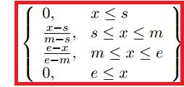

1. marks)

f) Given the following discrete fuzzy sets:

$$A=\left\{\left(3,0.4\right), \left(4,0.4\right), \left(5,1.0\right),\left(6,0.4\right),\left(7,0.1\right)\right\}$$

$$B=\left\{\left(3,0.2\right), \left(4,0.5\right), \left(5,0.9\right),\left(6,0.9\right),\left(7,0.3\right)\right\}$$

Calculate the following:

1. The union of the fuzzy sets A and B.
$$A⋃B=\left\{\left(3,0.4\right),\left(4,0.5\right),\left(5,1.0\right),\left(6,0.9\right),\left(7,0.3\right)\right\}$$

2. The intersection of fuzzy sets A and B.

$$A∩B=\left\{\left(3,0.2\right),\left(4,0.4\right),\left(5,0.9\right),\left(6,0.4\right),\left(7,0.1\right)\right\}$$

(4 marks)

Q2.

1. Fuzzify the following concepts by defining *three fuzzy sets for each*. You are also expected to draw appropriate membership functions for each fuzzy set, and label appropriately:
2. Temperature
3. Intelligence
4. Credit Score

4 marks for each fuzzified concept. Sensible use of membership functions along with a sensible number of fuzzy sets. Sensible distribution of each membership function. Well labelled

1. marks)
2. The Gaussian membership function for the variable $x$ is defined as:

$$m\left(x\right)= e^{[-{\left(x-c\right)}/s]}$$

Where $c$ is the centre and $s$ is representative of the width. If one assumes that $x$ takes any value between $0$ and $10$, and that $c=5$, describe using a diagram or descriptively, what the membership function will look like when:

$s=1000$

If the value for sigma is relatively high given the scope for the x-axis, the plot will essentially be almost a straight line where the degree of membership is equal to 1 on the y-axis. Every value will most likely score 1 for its degree of membership.

$s=0.001$

Having a very small value for sigma, will have the opposite effect. Using a value of 0.001 will essentially provide for a straight line with little to no distribution. The only point on this plot where a value can return anything other than 0 for its returned degree of membership will be at the value specified for it centre, i.e. 5

1. marks)
2. Describe, using either a diagram or the mathematical formula, the *Trapezoidal* membership function.

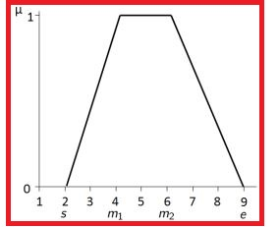

Or\and

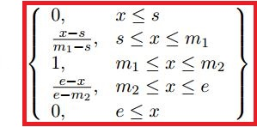

(5 marks)

1. The following fact and rules are part of a forward chaining rule based system:

Healthy $\left('Bob'\right)$

1. IF Climbing $\left(X\right)$ OR Cycling $\left(X\right)$ THEN Healthy $\left(X\right)$
2. IF Running $\left(X\right)$ AND OnDiet $\left(X\right)$ THEN Healthy $\left(X\right)$

What are all possible conditions that could have resulted in this fact being TRUE?

Climbing(‘Bob’)

Cycling(‘Bob’)

Running(‘Bob’) AND OnDiet(‘Bob’)

(3 marks)

Q3.

1. There are two main serach algorithms used in artificial intelligence, describe these two methods

Forward chaining algorithm:

While new facts are being asserted

For each rule in the rule base

Attempt to fire the rule

If the rule fires, assert the consequent as a new fact

It is data driven

It is often associated to the breadth first search algorithm.

Backward chaining algorithm

Given a goal G

If G is true then

Return TRUE

Else

Identify rules which could cause G

If one rule or more is found then

Set antecendent premise a subgoal and recurse

Else

Return FALSE

It sis goal driven

It is often associated to the depth first search algorithm.

(10 marks)

1. Consider the following facts and rule base; showing all working, use forward chaining to find one of Michelle’s cousins. You may express the all or part of the solution as a tree:

FACTS:

Father(Tom, George)

Father(Tom, Pete)

Father(Tom, Jane)

Father(George, Alice)

Father(George, Dave)

Father(George, Fred)

Father(Pete, Claire)

Father(Pete, Michelle)

RULE BASE:

IF Father(X,Y) AND Father(X,Z) THEN Sibling(Y,Z)

IF Father(X,Y) AND Father(P,Q) AND Sibling(X,P) THEN Cousin(Y,Q)

Ordering is very important, should go top to bottom in the knowledge base.

Fire rule 1:

Sibling(George,Pete)

Sibling(Pete, Jane)

Sibling(George, Jane)

Sibling(Alice,Dave)

Sibling(Alice,Fred)

Sibling(Dave, Fred)

Sibling(Claire,Michelle)

Fire Rule2:

Cousin(Alice, Claire)

Cousin(Alice,Michelle)

We can stop here but forward chaining would continue until not more rules fire.

Can also express this answer as a tree.

(10 marks)

1. Describe the components of an Expert System, a well-defined diagram is acceptable.

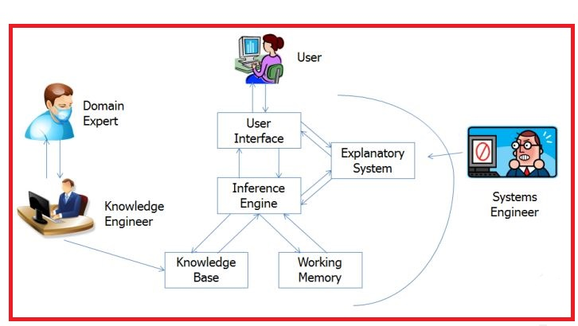

Something similar to the above diagram. Making sure to have the knowledge base and inference engine components included, as well as the domain expert and explanatory system and the uer interface.

(5 marks)

Q4.

Consider the following simple Mamdani fuzzy logic system with *two inputs* and *one output*, used to control a large marine engine. The system has two input variables each with *two fuzzy sets* and a single output variable also with two fuzzy sets. The two input variables are *Engine Load* measured as a percentage [0,100] and *Desired RPM* measured in RPM on the scale [0, 5000]. The output variable is *Fuel Rate* with two sets high and low measured in *l/hr* on a scale of [0,500]. All fuzzy sets in this system are trapezoidal and their respective parameters are given in the following below:

|  |  |  |  |  |  |
| --- | --- | --- | --- | --- | --- |
| Domain | Name | Start | Middle 1 | Middle 2 | End |
| Engine Load | Low | 0 | 0 | 25 | 75 |
| Engine Load | High | 25 | 75 | 100 | 100 |
| Desired RPM | Low | 0 | 0 | 1000 | 4000 |
| Desired RPM | High | 1000 | 4000 | 5000 | 5000 |
| Fuel Rate | Low | 0 | 0 | 100 | 400 |
| Fuel Rate | High | 100 | 400 | 500 | 500 |

1. Using the information contained in the above table, sketch out the inputs and output variables. Correct use of labels is expected.

(6 marks)

1. Fuzzify the following values in the fuzzy sets Low and High for Engine Load and Desired RPM:

Engine Load = 50 Desired RPM = 3000

EngineLoad Low(50) = 0.5 High(50) = 0.5

DesiredRPM Low(3000) =0.33 High(3000) = 0.66

(2 marks)

1. Using your answer from part b) calculate the firing strength of the following two rules when using the minimum t-norm:

RULE 1: If Engine Load is Low and Desired RPM is Low Then Fuel Rate is Low

Rule 2: If Engine Load is High and Desired RPM is High Then Fuel Rate is High

Rule 1: min(0.5,0.33) = 0.33

Rule 2: min(0.5,0.66) = 0.5

(2 marks)

1. Using you answer to part c) and the graph paper provided, draw the result of the implication operator (fire the rules) on the consequent sets of the rules listed in part c) using the minimum t-norm.

There will be two trapezoidal plots, one for Fuel Rate LOW, the other for Fuel Rate HIGH.

Assuming that the plot for each of the two fuzzy outputs is correctly scaled using the parameter values given, a line for the first plot: Fuel Rate LOW, will intersect the membership function at 0.33, they should shade in the area under this intersection line with regards to the membership function.

The second plot: Fuel Rate HIGH, will intersect the membership function at 0.5, they should also shade in the area under this intersection line with regards to the membership function.

The plots should be aligned such that plot 1 is directly above plot 2.

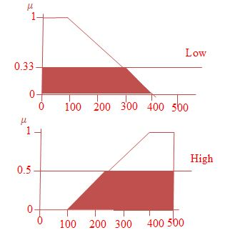

(7 marks)

1. Using an example of your own choice explain how a fuzzy set captures the notion of vagueness better than a crisp set.

A descriptive type question. 2 marks for sensible example, 2 marks for how the example would have been captured using strict means. 1 mark for the highlighting the advatages of a fuzzy approach.

1. marks)
2. The Mean of Maximum of fuzzy set $A$ can be calculated using the following formula:

$$MOM_{A}=\frac{\sum_{i=0}^{N}{{max⁡(μ}_{A}}(x))x_{i}}{\sum_{i=0}^{N}{{max⁡(μ}_{A}}(x))}$$

Where

$$\max\left(μ_{A}\left(x_{i}\right)\right)=\left\{\begin{aligned}1, &x_{i}=∨_{x∈X}μ_{A}(x) \\ 0, &x_{i}≠ ∨_{x∈X}μ_{A}(x)\end{aligned}\right.$$

Calculate the Mean of Maximum of the following sets:

$A=\{\left(2,0.25\right), \left(3,1\right),\left(4,0.5\right),\left(5,1\right),\left(6,0.66\right),\left(8,0.33\right),\left(9,0.2\right)\}$

$$\frac{3+5}{2}=4$$

$B=\{\left(3,0.3\right), \left(3.5,0.66\right),\left(4,0.66\right),\left(4.5,0.5\right),\left(5,0.66\right),\left(5.5,0.5\right),\left(6,0.2\right)\}$

$$\frac{3.5+4+5}{3}=4.17$$

(3 marks)